INGLÉS 7° A TT
DIAGNOSTIC PERIOD 7TH FORM
Familias: Les envío el siguiente material para poder trabajar estos días en casa, si no tienen impresora en casa pueden copiar las actividades en la carpeta o directamente las respuesta y al retorno las corregimos juntos.
Cariños . Miss.Dani

EXERCISE 1

Complete with is/are /am
My name Sandy. I at school now.
I busy now because I working on a family project and I (not) ready yet.
Look at the picture above! This my family and they all its members:
He Bob, my brother. He a bit naughty but very sweet. They my grandparents, Tim and Helen. They the best but they (not) in Argentina at the moment. They like travelling and I miss them a lot.
And those in the middle my parents. I love them very much!
My family great!
Oh, it’s late! I have to colour my picture. Bye!

EXERCISE 2

To revise was/were

EXERCISE - TO BE in the SIMPLE PAST
Complete the sentences with the correct form of the verb to be in the past form:
1. | He an engineer.
2. | I cold - please close the window.
3. | My sister 22 years old.
4. | Mr. Squire a waitress.
5. | We always at home on the weekend.
6. | It a beautiful day for a picnic.
7. | They at home yesterday morning.
8. | They from Canada. They were from The Up.
9. | My father shies when he was 5 years old.
10. | They good at art.

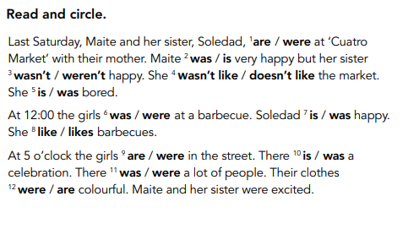
EXCERCISE 3

- A continuación te dejo unos links para practicar Simple Past. . Espero que te sirvan. Cuando termines de resolverlas hace click en CHECK y el mismo sistema te va a decir en que te equivocaste.
https://agendaweb.org/exercises/verbs/past-simple/regular-forms
https://agendaweb.org/exercises/verbs/past-simple-regular

GOOD LUCK!

